Lumecca Case Studies

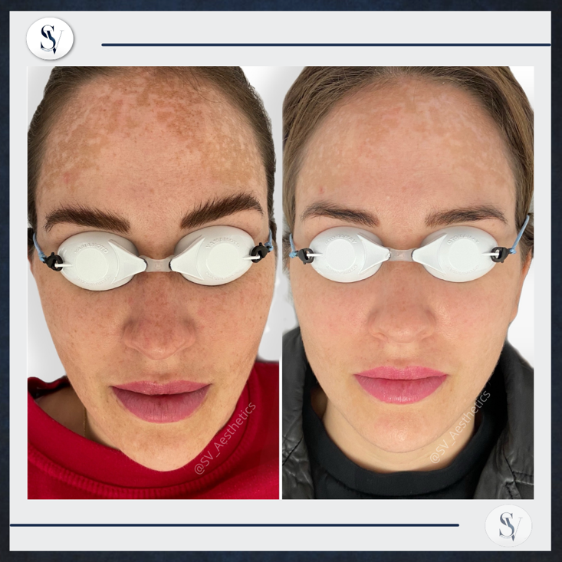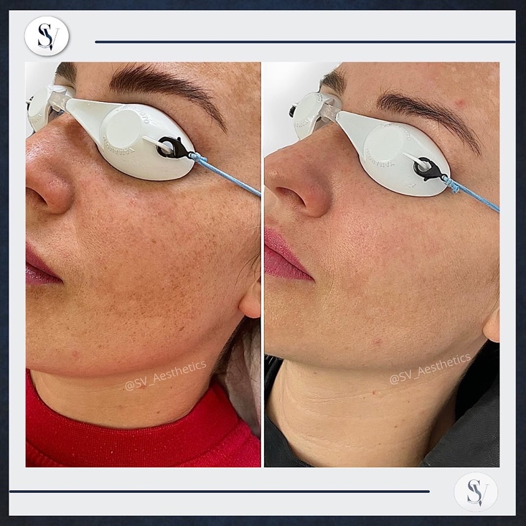

Physician: SV Aesthetics

Procedure: Lumecca IPL 515nm

Number of Sessions: Before & After 2 Sessions on Full Face

Age: Female, 34

Area Treated: Full Face

Energy: 10 J/cm2

Cooling: Strong

Description/More Details:

Female with skin type 2 requested treatment to reduce pigmentation (with emphasis on forehead). These are the results after 2 sessions. On each session we did one pass on the entire face & a 2nd lower pass after 15 minutes on a 20% reduced settings – we avoided the forehead on the 2nd pass. Pigments darkened after each session & then became lighter. We will complete another session & review the results.